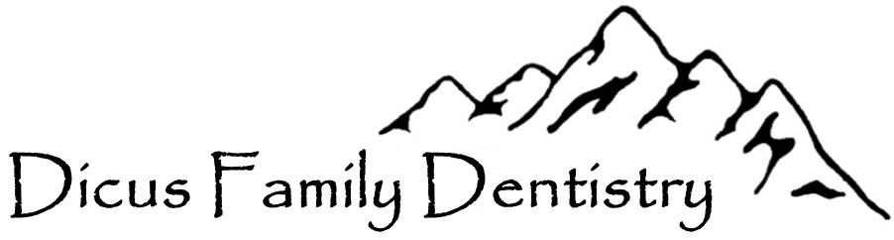

Patient Authorization to Release Confidential Information

I __________________________ hereby authorize the release of dental records for:

___________________________ ___________________________

From Former Office: ________________________________________

To be released to: Dicus Family Dentistry
15 McCabe Drive, Suite 201
Reno, NV 89511
office@dicusfamilydentistry.com

These records include, but are not limited to: personal information, medical and dental histories, examination records, radiographs, clinical photographs, treatment plans, treatment records, referral and consultation recommendations and reports, diagnostic models, and other related materials.

I expressly release from liability the above-named person or entity from any and all liability arising from compliance with this request and disclosure of the requested information.

Signed:___________________________________Date:_____________________
(Patient or Parent/Guardian)

Michael T. Dicus, D.M.D.
15 McCabe Drive, Suite 201
Reno, NV 89511
(775) 828-7246 phone
(775) 852-2300 fax
office@dicusfamilydentistry.com (secure email)

